2018 FALL-WINTER NEWSLETTER

President’s Column
By Tom Lindblom

I'm honored to have been selected to be the President of Friends of Niños Adelante. My first exposure to this group was nearly twenty years ago when my parents (Leif and Lois) became involved and sponsored the first of many students. During annual trips to Zihuatanejo my Dad joined Ty Bujold and others as one of the founding teachers for the sponsor taught Niños English program.

According to our most recent statistics 80% of our high school graduates now go on to a college or university. Earlier this year Niños student, Jorge Alberto was named the Valedictorian of his Nursing class - the second consecutive year that a Niños student earned this honor at Instituto America. The recipient of this year's Irene Sheahen Scholarship, Bella Vanessa graduated from High School with a perfect 10.0 GPA and is now going on to study biology at the university in Morelia. These are two examples out of many where your generosity in sponsoring at risk students is changing lives and making a big difference in the community.

In 2005 the program expanded from what had been a K-12 program to include those going on to higher education. The costs of college vary greatly and one of my objectives in the coming year is to explore options to increase the number of scholarships and level of support we can offer to our college students. I’d love to hear your ideas and suggestions – please send them to me at tom@tomlindblom.com via email.

Lastly, I wanted to share that Jim Moe has retired from the board. I join the board in thanking him for his five years of service on the board. Jim continues to be active in the organization and we look forward to his ongoing participation.

See you next spring in Mexico.

Tom

New USA Tax Law Changes – Direct IRA Contributions

With the recent tax law changes and the new limits on itemized deductions, I'm told that those sponsors that are 70 1/2 or older can now arrange to make contributions directly from their IRA's to 501(c) charities such as Friends of Niños Adelante. This can be structured to decrease your taxable IRA amount. To accomplish this, tell your IRA fiduciary who/what/where to make the donation (you do not touch it). They will then give you a letter acknowledging they sent it, and the charity should give you a letter saying they received the contribution from your IRA. This distribution then counts towards your RMDs (Required Minimum Distributions), and if your tax advisor has the two letters they can deduct that amount from the IRA distributions that are taxable. As always, consult your tax advisor for details about your specific situation.

https://www.fidelity.com/building-savings/learn-about-iras/required-minimum-distributions/qcds

https://www.kiplinger.com/article/taxes/T054-C032-S014-qdcs-a-strategy-to-get-more-from-2018-rmds.html

2019 SPONSOR/STUDENT REUNION BREAKFASTS

This is the time to see your becado, hear about current Niños Adelante activities and experience the energy of a room full of kids and parents who appreciate the support they receive from Niños Adelante. Translators will be available to help you and your becado get the most out of this experience.

Please use these Breakfasts to meet and visit with your student and his or her family in place of having José arrange a private meeting. As you can well imagine, the months of January and February are very chaotic for José.

Breakfasts will be held at the Hotel Fontan in Ixtapa at 9:30 A.M. on Sunday, January 13, 2019
and 9:30 A.M. on Sunday, February 10, 2019.

Register now! José must notify your becado to attend the breakfasts. This notification takes place during beca payout day on the first Saturday/Sunday of the month in which the breakfast will be held.

R egi str a t i o n D e adl i n es
January 13 breakfast – December 31; February 10 breakfast - January 31

As in the past, padrinos are responsible for their becados and their family’s breakfasts. Cost of breakfast is expected to be about $12 per person.

REGISTRATION FORM

Please PRINT and complete the following form and send to:
Friends of Niños Adelante, PO Box 1624, Sonoma, CA 95476

Please reserve places for me at the January 13 Breakfast.
Please reserve places for me at the February 10 Breakfast.
I will be staying at in Ixtapa/Zihuatanejo from
/ and departing on / (this helps José communicate with you, if necessary).

My name is: .

If you would like to host the student and his family of a friend who cannot be at the breakfast, please give us the Sponsor’s name: .

Note: Please include only yourself and your family and friends in the count of guests below. José will contact the students and their families to determine the number of students and family members attending.

2019 ANNUAL BENEFIT DINNER
REGISTRATION FORM

The annual benefit dinner will be held this coming February in Ixtapa on either Wednesday or Thursday, February 13 or 14, 2019, Refreshments at 5:30 p.m. We are investigating a new venue in Ixtapa, close to the Marina and will have an update on the possibilities of this new location soon.

The 2018 event raised just over $4000 for our Special Needs and College Scholarship Funds. What a wonderful way to enjoy a fabulous meal, complete with refreshments, at a very special place and help a great cause at the same time.

Please register early! Please PRINT and complete this form and send it along with your check, payable to Friends of Niños Adelante to the address below.

If you wish to pay via a credit card please visit our website at www.friendsofninosadelante.org and use the registration form and PayPal provisions found there.

Reserve _______ seat(s) at $100 each. Amount enclosed for dinner $ _______ .

Names of attendee’s __________________________________________________________________________

I am unable to attend the Benefit Dinner but enclosed is my tax-deductible donation of $___________.

Thank you, Tom Lindblom

Please mail form and check to:
Friends of Niños Adelante
PO Box 1624
Sonoma, CA 95476

2018 Scholarship Update

This year the scholarship committee is happy to report that we have awarded two scholarships.

The Irene Sheahen Memorial Scholarship was awarded to a young woman who achieved a perfect 10 G.P.A. Her name is Bella Vanessa Rodriguez Cabrera. She is studying Biology at Nicolas Hidalgo University in Morelia. Her sponsors are Mike and Kathy Gallagher.

The Nick August Scholarship was awarded to Sael Madora Sanchez. Sael will be attending college at UT Petatlan. His sponsor is Doug Scheving.

Irene Sheahen Scholarship Recipient
My name is Bella Vanessa Rodriguez Cabrera, I was in my last year of junior high school when I joined Niños Adelante. It's already been four years, and for all this time I´m completely grateful to this great foundation.

I grew up next to my parents and my brother, I went to kindergarten in a small town near Acapulco, called El Cayaco. At that time my parents were fishers and on weekends I accompanied them to their work.
My other studies took place here in Zihuatanejo because I have been living here for 10 years.

Since I was little I liked going to school and learning, that's why I finished Elementary and junior high school with good grades. Now I'm about to graduate from high school, my grades are also very good. I have confidence in myself and I believe that if I try hard I will become a good professional.

I have many goals and dreams to fulfill, with the help I have received every time I get closer to them. I want to become a person with principles and values, help other people and help my family. Being a good person.
A while ago I did not know what I wanted to do for the rest of my life, it was not until recently that I realized, now what I really want to be is a Biologist. I imagine living happily dedicating myself to that.

My mother only finished Elementary school and my father high school, for me they are professionals and they are the best where they work, despite this their jobs are not well paid, but thanks to them I have gotten where I am now. For us, the fact that I go to the university in another city represents a great challenge, but there are no closer universities that offer the career that I want to study so I must move there. The university in which I was accepted is in Morelia, I do not have family there so the expenses will be many. It will be difficult to afford them.

For these reasons I would like to be a candidate to obtain the special scholarship. It would be a great help for my parents and me. I would appreciate very much if you would consider my request. Again, I thank all those who are part of Niños Adelante. In the future I would like to return all the help you have given me and the other kids.

Nick August Scholarship Recipient
My name is Sael Alexander Madora Sanchez, I am a current student with my regular sponsor Douglas Scheving and I am in the technological university of la Costa Grande de Guerrero in Petatlán. Because of my studies I am living in Petatlán. I am pursuing a career in technologies of information and communication in multi-platforms. Known as tics, I got into the university with an average of 8.4.

I am so grateful for this surprise, being the winner of the Nicolas August scholarship, this will help me for the expenses pertinent to my studies and is a great support. Being the eldest son of a family of four children, this is something that I am grateful for since with this I will be able to better help my parents with expenses for my studies.

I say goodbye with a cordial greeting and I wish you a nice day in the company of your loved ones and may God bless you and all your loved ones.

Student Update – Nancy Fiore

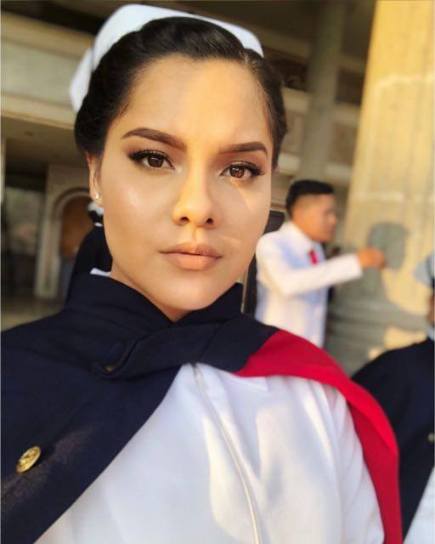
Dear godparents (Sponsors Jocelyn Servick & Gary Steinhafel)

I hope you are well, I am very happy because I just finished the school, Friday was my last day of practice in the hospital.

On Thursday I went to a nearby town from Zihuatanejo to choose the place where I will do my social service. I will start my service on August 1st at the General Hospital in Zihuatanejo, I am very excited because I always wanted to do it there.

My graduation ceremony will be on July 6th, I feel very nervous because I will give the graduation speech. All of this wouldn’t be possible without your unconditional support, I am very happy to finish an important stage of my life thanks to you.

Finishing my career wasn’t so easy, but I couldn’t be more grateful to have people who always offered me their love and support.
Thank you for always trusting me.

Student Update – Ana Laura Ramírez García
Hi Godparents (Sponsors Chris and Katerina Papageorgio)

Firstly, thanks very much for your support. I want you to know that you are a reason in my life to continue ahead and always I thank a God for putting very good people with a big heart in my way. May God bless and protect you always, may He always fill you with blessings and love in your family.

For my first year at university it went very well, although it was a big change from the high school to university. In university I met new friends and teachers, they taught me new things and helped me grow as a person.

In the first semester in the university I went to a cultural extracurricular activity. I chose the reading workshop and I liked it a lot because we read reflexion readings and we did a story as final work. In the second semester i went to a sports extracurricular activity and I chose chess. I went to classes in February. I did not know how to play and now I like it a lot because it is a game that makes you think a lot. I am happy because I played a little chess and I learned the movements of the pieces, but I hope to continue learning more because it is a fun game.

My family and I are fine, now my dad and my mom are living with my grandmother because my dad is working in the town, my brothers and I are going to visit them on vacation, we went on a March vacation and I was very happy because I live more with my family and I met more cousins ​​because I do not know everyone, my brothers and I hope to go in July.

In English classes I'm doing well, I've learned a lot of things and little by little I'm learning to listen to it and speak it. I'm really wanting to learn more and when I see you then I can communicate with you.

I hope to see you soon, I miss you and I send you kisses and hugs and I hope you write me soon.

Amazon Smile Benefits Friends of Niños

By using the Amazon Smile program you can benefit Friends of Niños Adelante and it doesn’t cost you anything. Signup is at https://smile.amazon.com/ and you only need to select Friends of Niños Adelante one time and then (important) place future orders from the smile.amazon.com page. This then automatically generates a contribution for every purchase. Please pass this on to all of your contacts and let’s see if we can build another source of income for our Friends of Niños organization. Thanks to all for helping us out and from the kids!

Student Update - Dannia Belén Quiroz Sánchez
(Sponsor Millar & Janet Drummond)

Once again, I have completed another school year, the second one of high school and I want to say thank you for helping me one more year, the fifth one. Your help is so important for me because it’s what gives me the possibility to keep studying.

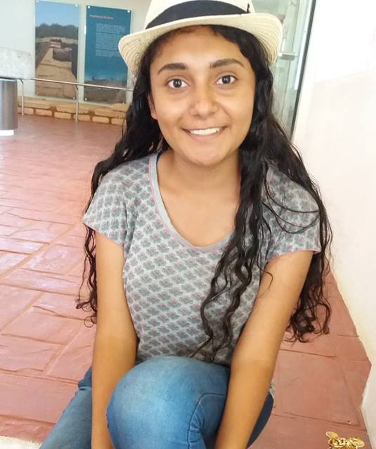
I really enjoyed this school year because I lived different experiences, as well as I could keep good marks that I always dedicate to my parents and sponsors.

I was in an oratory competition in my school and at the beginning I felt so insecure because I thought I wasn’t good enough and I would surely lose, but then I thought that I could do whatever I want with effort. I couldn’t get the first place, but I got the third place, and I feel so satisfied because at first I never thought I could get something, and I also made new friends.

During this school year I trained and did an exam for the Cambridge English certificate (level B1) on December 1st and I passed it. I feel so happy because this certificate is so important for getting a job, it’s the key that will open doors.

The new school year is about to begin, and I know it will be totally different, I’ll have new subjects and it’s the last one in high school, which means that I’ll have to work harder and also keep good marks.

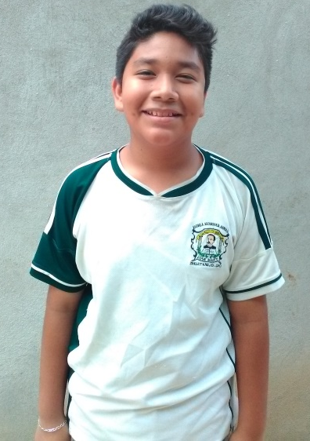
Student Update – Dante Josue Mendoza Lorenzano
dear Godparent (Sponsors Ron and Bonnie Wagner)!

My name is Dante Josué Mendoza Lorenzano I’m 13 years old, I’m going to begin the 8th grade of the Junior High School. Thank you for supporting me this year, I’m going to do the best at school. My hobbies are play volleyball, soccer, listen music, also I like to sing and do things with recycle material.

I have 3 siblings, my brother Aldo is 22 years old is the oldest of them then my sister Alejandra is 21 years old and my sister Dayra is 11 years old is the youngest. I live with them and with my motheri n Zihuatanejo, Gro., also I have four pets one is a cat it name is Cleo, one dog called Megan, a bird Blue, and a Turtle that it name is Turtle. This year my Sister Dayra will finish the primary,and my sister Alejandra almost finish her career.
In the secondary I’m in the school workshop of food preparation and preservation, we form a small groups and sometimes we did a practice about prepare food.

This summer I want to learn to play the guitar, in Zihuatanejo downtown there is a place where some people go to learn, so I’m considering go with them and finally learn to play the guitar. But I want to join a group of volleyball too.

Hope you’re fine, my family and I sent greetings for all. With love Dante Josue

Student Update – Hannia Guadalupe Campos Llamas
(Sponsors Jay and Doris Schroeder)

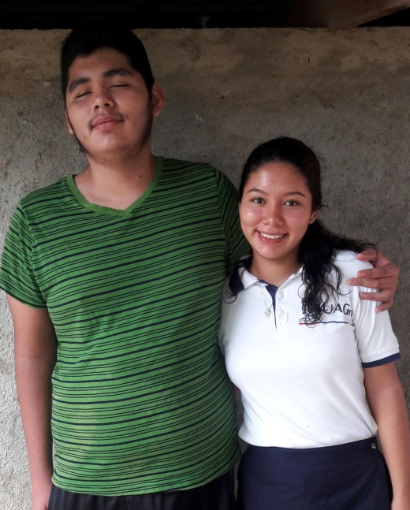
Hi godparents, how are you?. My family and I are very good now, I hope you are very good too. Everything is good in my school and in my house also, eleven grade is ending. It was a great school year, because I learned many things in my different subjects, my favorite class was biology, there I learned interesting things about genetic, and molecular and cellular reproduction. I do not have my report card yet, as soon as I have it I will send you a photo. I'm very excited to start twelve grade, because in twelve grade I have to choose an optional or subject oriented in the career that I will study in the University. The optative that I will choose is Anatomy, and in 6th semester it changes to clinical analysis since these are the subjects that I need to study Dentistry. I hope to meet the dentist Elizabeth soon to talk about it.

I hope this summer will be good. I'm very excited for summer of research, and I'm happy because my birthday seventeenth and Hugo's is going to be soon, my mother says that she is going to cook pozole. Do you like pozole? I really like it. I send you this image of my brother Hugo and me, you can see that he is taller than me, but you are tallest than Hugo and me. Hugo is very well, he sends you a big hug, he is excited to start the guitar lessons but although the teacher has not returned from his trip. My sister Ylianet is ending seven grade, she had a great school year too, and she is very happy to start eight grade. Currently it is rainy season here, I hope this helps to make it less hot.

I'm very lucky to have you like my godparents. My family and I send you a big hug for both, we love you. Thank you for being part of my life. Love you, Hannia.

Student Update – Christopher Jair
(Sponsors Michael Farnsworth and Claudia Peppy)
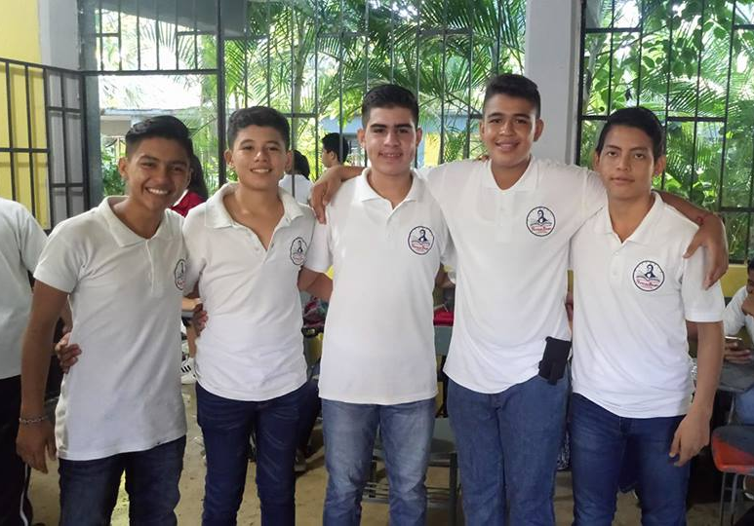
Hello godfathers, first of all I would like to greet you and, above all, thank you for all the support you have given me over these years. I am very happy, because I finished another school year and I will start a new one, since I am about to attend the third year of high school and I am very excited about that. In this year, I have fun things in high school and out of it, I am in the dance group of my high school and we have achieved many awards thanks to the presentations we have made.

On the part of the school, I was doing practices focused on the bachelor that I will choose to study (physicist-mathematician) so I was sent to the town hall with some architects to check planes and learn things that civil engineers do. I also did work with some public accountants, since I am also taking a training for that and it seems that I liked that and can help me a lot in choosing my career. At school I go very well in my grades and I hope to continue like this in order to reach a good average at the university and be able to finish it without any problems.

I hope you continue to support me because the truth is very expensive to keep studying, I would like to go to the capital of the country to study there at the university but my resources are not enough to achieve it. As I mentioned my favorite pastime is dancing, so I'm very focused on it, I'm in a folklore and contemporary dance school and I've learned a lot of things and I've been filled with a lot of discipline since it's a lot of physical work that's dancing. I say goodbye to you again, thanking you for all the support you have given me and I am still hoping to get to know you one day. Goodbye.

Student Update – Lucero Inahi
(Sponsors Ewing and Marjorie Jones)
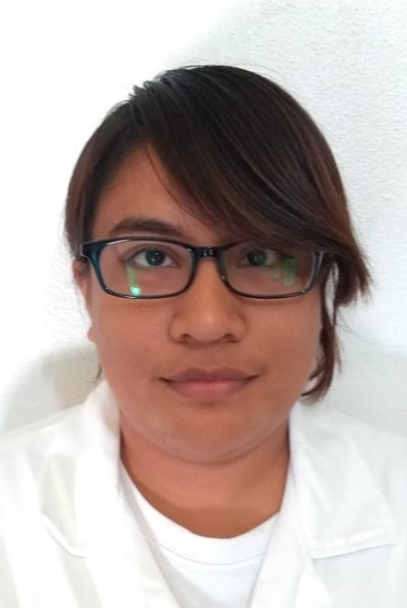
I am continuing with my studying for a degree in Pharmacobiology Chemistry at the Michoacana University in the city of Morelia, Michoacán, culminating the 3rd year. In August I will start the 4th year of study, keeping in mind that 5 years of study plus 1 year of service in my field of study will be required to complete my degree. I thank my sponsors Ewing and Marjorie Jones for the support they have given me since entering high school, continuing with me in high school and now in college. You have been a very important part throughout my life and learning just as you have been for my mom, my brother Eric and my sisters Diana and Britseida.

First I need to finish the QFB career and I want to enter the field to test in that area, after a year of work I would undertake to have a master's degree that will help me to reinforce my knowledge.
Next year I will begin my paperwork to obtain my passport and visa and be able to travel to the US to visit with you and give personal thanks for the support given to my family and me.

My mom sends many greetings and is making an embroidered tablecloth for Marjorie. My sister Diana has completed her 4 years of nursing study and her year of internship to receive her professional nursing license and Briz who has completed her study to become a teacher is about to get her professional teaching degree along with her certificates. Also, as you know my brother, Eric Daniel is finishing his doctorate in the field of Pharmacobiology at UNAM.
Lucero and family

Student Update – Perla Lizbeth Benitez Cortes
(Sponsors Mike and Linda Smith)
Hello Godfathers, first of all, I hope everything has improved in terms of my godmother's health, for me it is a little difficult not to know about you and even more in that situation, I have tried to communicate with you through Mr. José Bustos, since I know that he has more accessibility in that regard, I would be very happy to receive an email or to notify me of anything with Mr. Bustos.

This letter is to inform you that I will go to the third year of University, everything has gone very well, my enthusiasm for the school remains the same as I continue to strive and that is reflected in my good grades, I also do it for you Take into account that I thank you for all the support you have given during these years in the foundation.
I had previously written to let you know that I was in the process of finishing the second year and that I would receive my first degree from the degree I am currently studying, now I start with the second stage which consists of receiving a second degree that is engineering, This makes me very happy because I have achieved many things and are more than I expected. Thank you so much!

I will be traveling from my house to the university since I did not like to rent because Petatlan is very unwelcoming, there are very few recreational places to distract me and the shopping centers are very small that made it very difficult for me and I feel very well to get home and be with my family in the afternoon.

Another thing that I would like to tell you about is the orthodontics that you gave me, very soon a year and a half of the treatment is completed, I attend all my appointments with the dentist and the truth is I am satisfied with the result, I will annex a photo for you to see what I tell you through this letter.

Website Questions/Comments
www.friendsofninosadelante.org tom@tomlindblom.com

